ADE7912, ADE7913, ADE7932, ADE7933 Data Sheet Detailed Change List
Parameter specification changes are listed as follows:
- ADC Offset Drift Over Temperature
From: -500 PPM/°C minimum, +500 PPM/°C maximum for V1 channel only
To: +200 PPM/°C typical for V1 channel only
- Gain Drift Over Temperature
From: -135 PPM/°C minimum, +135 PPM/°C maximum for current channel
-65 PPM/°C minimum, +65 PPM/°C maximum for V1 and V2 channel
To: -135 PPM/°C minimum, +135 PPM/°C maximum for current channel
-85 PPM/°C minimum, +85 PPM/°C maximum for V1 and V2 channel
- Input Current, Iin
From: 15 nA maximum
To: 0.015 uA typical, 1uA maximum
This product has achieved UL, CSA and VDE certification and absolute maximum rating changes are listed as follows:
- Regulatory Approvals
From:
UL | CSA | VDE
Recognized Under UL 1577 Component Recognition Program | Approved under CSA Component Acceptance Notice 5A | Certified according to DIN V VDE 0884-10 (VDE V 0884-10):2006-12
Single Protection, 5000 V rms Isolation Voltage | Basic insulation per IEC 61010-1, 400 V rms (564 V peak) maximum working voltage | Reinforced insulation, 846 V peak
Note: In accordance with UL 1577, each ADE7912/ADE7913 is proof tested by applying an insulation test voltage ≥ 6000 V rms for 1 second (current leakage detection limit = 10 μA).
To:
UL | CSA | VDE
Recognized Under UL 1577 Component Recognition Program | Approved under CSA Component Acceptance Notice 5A | Certified according to DIN VDE V 0884-10 (VDE V 0884-10):2006-12
Single Protection, 5000 V rms Isolation Voltage | Basic insulation per CSA 60950-1-07+A1+A2 and IEC 60950-1 2nd Ed.+A1+A2:  - 830 V rms (1173 V peak) maximum working voltage  Basic insulation per CSA 61010-1-12 and IEC 61010-1 3rd Ed. (pollution degree 2, material group III, overvoltage category II, III and IV):  - 300 V rms (424 V peak) maximum working voltage.  Reinforced insulation per CSA 60950-1-07+A1+A2 and IEC 60950-1 2nd Ed.+A1+A2:  - 415 V rms (586 V peak) maximum working voltage  Reinforced insulation per CSA 61010-1-12 and IEC 61010-1 3rd Ed. (pollution degree 2, material group III, overvoltage category II, and III):  - 300 V rms (424 V peak) maximum working voltage. | Reinforced insulation, 846 V peak
FILE E214100 | FILE 2758945 | FILE 2471900-4880-0001
In accordance with UL 1577, each ADE7912/ADE7913 is proof tested by applying an insulation test voltage ≥ 6000 V rms for 1 second (current leakage detection limit = 15 μA).
- Critical Safety Related Dimensions and Material Properties
From:
Parameter | Symbol | Value | Unit | Test Conditions/Comments
Tracking Resistance (Comparative Tracking Index) | CTI | >600 | V | IEC 60112
To:
Parameter | Symbol | Value | Unit | Test Conditions/Comments
Tracking Resistance (Comparative Tracking Index) | CTI | 400 | V | IEC 60112

- VDE Characteristics
From:
Description | Test Conditions/Comments | Symbol | Characteristic | Unit
Climatic Classification |  |  | 40/105/21
Surge Isolation Voltage | V_{PEAK} = 10 kV, 1.2 µs rise time, 50 µs, 50% fall time | V_{IOSM} | 6000 | V peak
To:
Description | Test Conditions/Comments | Symbol | Characteristic | Unit
Climatic Classification |  |  | 40/085/21
Surge Isolation Voltage | V_{PEAK} = 10 kV, 1.2 µs rise time, 50 µs, 50% fall time | V_{IOSM} | 6250 | V peak

- Thermal Derating Curve
From:
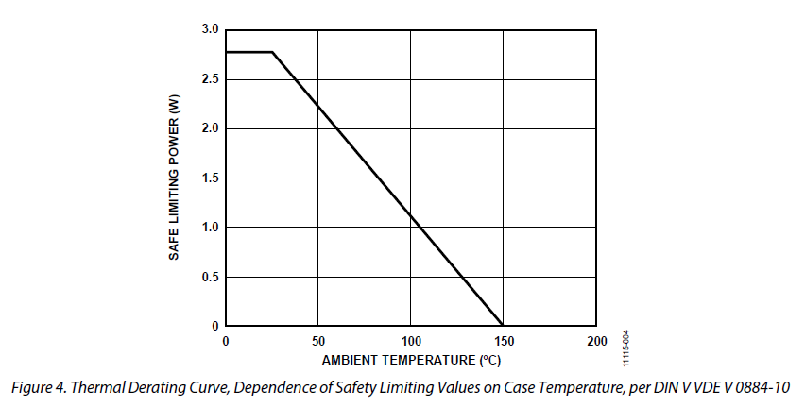
To:
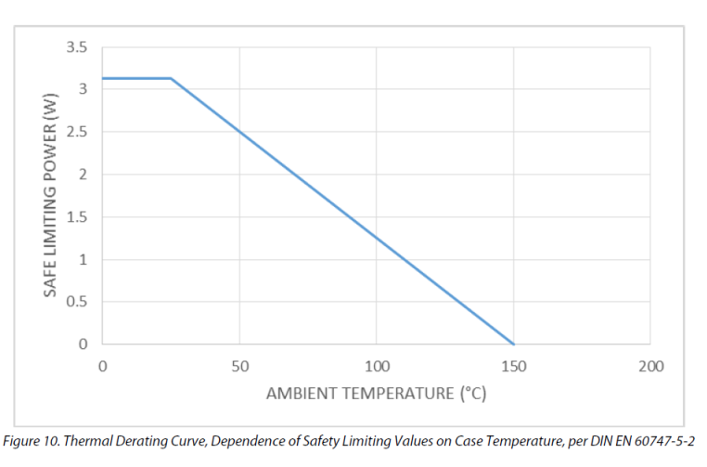
5. Maximum Continuous Working Voltage Supporting a 50-Year Minimum Lifetime
From: AC Voltage, Bipolar Waveform 564V peak
DC Voltage, Basic Information 600V peak
To: AC Voltage, Bipolar Waveform 400Vrms
DC Voltage, Basic Information 1173V peak

